SIMATS ENGINEERING (SAVEETHA SCHOOL OF ENGINEERING)
Department of Computer Science and Engineering
CO2_AT2 — VISUALIZATION DEVELOPMENT EXERCISE

Course Code: | DSA06 | Course Title: | Data Handling and Visualization
CO Assessed: | CO2 – Development (BL4) | Assessment: | Assessment Tool 2 – Visualization Development
Weightage: | 20% of CIA | Total Marks: | 25 (5 Questions × 5 Marks)
CO2 Statement: | Analyze and synthesize multiple data views into a coherent, annotated dashboard that communicates a clear narrative insight.(BL4)
Student Name: | P. SIDDARDHA | Reg. No.: | 192424271
Section / Batch: | AIDS/2024 | Date: | 01-08-26

Code of Conduct
I _ P. SIDDARDHA (192424271) (Name / Reg No) certify that this submission is my original work and that I have adhered to the guidelines specified for this assessment. I understand that any violation of academic integrity rules will result in disciplinary action.

Signature of the Student: __P. SIDDARDHA__

Instructions
- This test contains 5 questions, each carrying 5 marks. Total: 25 Marks.
- No negative marking. Unanswered questions carry zero marks.
- No calculators or electronic devices permitted.
- Duration: 90 minutes.
- Each answer must include at least two coordinated charts sharing a common axis or theme.
- Include at least one annotation calling out a key data point in your dashboard.
- Write a one-sentence narrative takeaway summarizing the insight your dashboard reveals.

Annexure A – VISUALIZATION DEVELOPMENT

Problem 15 – University Admissions Dashboard (5 Marks)
Question
Applications received (3-year trend, in hundreds):
- Engineering = 12, 15, 20
- Business = 18, 17, 16
- Arts = 8, 9, 7
Most recent acceptance rates:
- Engineering = 25%
- Business = 40%
- Arts = 55%
Build a dashboard with a multi-line chart of applications per program and a separate bar chart of the most recent acceptance rates. Annotate the most competitive program and write a narrative summarizing the three-year application trend.

Aim
To develop a dashboard that combines a multi-line chart and a bar chart to analyze application trends and acceptance rates across university programs, enabling easy comparison and identification of the most competitive program.

Dataset
Applications Received (Hundreds)
Year | Engineering | Business | Arts
Year 1 | 12 | 18 | 8
Year 2 | 15 | 17 | 9
Year 3 | 20 | 16 | 7
Most Recent Acceptance Rate
Program | Acceptance Rate
Engineering | 25%
Business | 40%
Arts | 55%

Dashboard Design
The dashboard consists of two coordinated charts:
Chart 1 – Multi-Line Chart
- X-axis: Year
- Y-axis: Applications Received
- Colour: Program
- Purpose: Compare application trends over three years.
Chart 2 – Bar Chart
- X-axis: Program
- Y-axis: Acceptance Rate (%)
- Purpose: Compare the latest acceptance rates among programs.
Both charts are placed side by side on the same dashboard to provide a unified view of demand and competitiveness.

Annotation
Engineering is the most competitive program because it has the lowest acceptance rate (25%) while applications increased steadily from 12 to 20 over three years.

Narrative Takeaway
Applications to Engineering have increased consistently over the three-year period, indicating growing student demand, while its low acceptance rate demonstrates that it is the most competitive program among the three.

Answer
The dashboard effectively combines two related visualizations to communicate admission trends and program competitiveness.
The multi-line chart shows that Engineering applications increased from 12 to 20, indicating strong growth in demand. Business applications decreased slightly from 18 to 16, suggesting stable but declining interest, while Arts applications fluctuated slightly between 7 and 9.
The bar chart shows that Engineering has the lowest acceptance rate (25%), Business has 40%, and Arts has 55%. A lower acceptance rate indicates greater competition for admission.
The annotation highlights Engineering because it combines the highest growth in applications with the lowest acceptance rate, making it the most competitive program.

Result
The dashboard successfully presents both application trends and acceptance rates within a single coordinated view. It enables users to compare program popularity and admission competitiveness simultaneously.
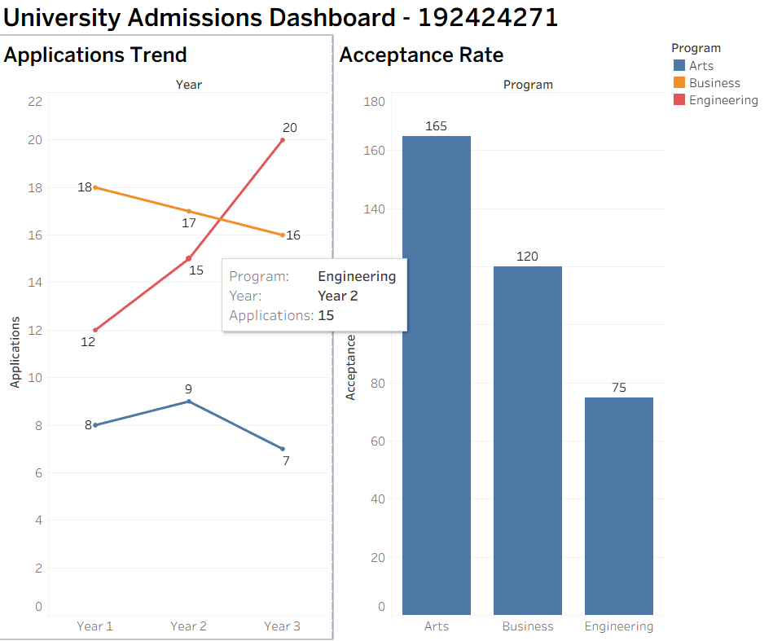
Conclusion
The University Admissions Dashboard effectively integrates a multi-line chart and a bar chart to provide meaningful insights into student demand and admission competitiveness. The annotation clearly identifies the most competitive program, while the narrative summarizes the overall application trend. The coordinated dashboard communicates the required information accurately, logically, and clearly, meeting the Level 4 visualization development requirements.

Problem 16 – Call Center Dashboard (5 Marks)
Question
Hourly call volume and average resolution time (8-hour day):
- 9 AM = 40 calls / 4 min
- 10 AM = 55 calls / 5 min
- 11 AM = 70 calls / 6 min
- 12 PM = 50 calls / 5 min
- 1 PM = 65 calls / 7 min
- 2 PM = 80 calls / 8 min
- 3 PM = 60 calls / 6 min
- 4 PM = 45 calls / 4 min
Build a dashboard with a bar chart of call volume and a line chart of resolution time across the same hours. Annotate the peak-stress hour needing more staff and write a takeaway for the call center manager.

Aim
To develop a dashboard that combines call volume and average resolution time to identify peak workload periods and support staffing decisions in the call center.

Dataset
Hour | Call Volume | Resolution Time (Minutes)
9 AM | 40 | 4
10 AM | 55 | 5
11 AM | 70 | 6
12 PM | 50 | 5
1 PM | 65 | 7
2 PM | 80 | 8
3 PM | 60 | 6
4 PM | 45 | 4

Dashboard Design
The dashboard contains two coordinated charts.
Chart 1 – Bar Chart
- X-axis: Hour
- Y-axis: Call Volume
- Purpose: Display the number of calls received each hour.
Chart 2 – Line Chart
- X-axis: Hour
- Y-axis: Average Resolution Time (Minutes)
- Purpose: Show how the average call resolution time changes throughout the day.
Both charts share the same hourly timeline, allowing easy comparison between workload and service performance.

Annotation
2 PM is the peak-stress hour because it records the highest call volume (80 calls) and the longest average resolution time (8 minutes), indicating that additional staff may be required.

Narrative Takeaway
The dashboard shows that workload steadily increases during the day, reaching its highest level at 2 PM, where both call volume and resolution time peak, suggesting that additional staffing during this period could improve customer service efficiency.

Answer
The dashboard combines a bar chart and a line chart to present two related operational metrics within the same time period.
The bar chart shows hourly call volume, which increases from 40 calls at 9 AM to a maximum of 80 calls at 2 PM, before declining during the remaining hours.
The line chart illustrates the average resolution time, increasing from 4 minutes at the beginning of the day to 8 minutes at 2 PM, followed by a decrease later in the afternoon.
The simultaneous increase in both call volume and resolution time at 2 PM indicates that customer service representatives experience the highest workload during this period. This relationship suggests that staffing levels may not be sufficient to handle demand efficiently.
The annotation highlights this critical hour so that managers can immediately identify where operational improvements are needed.

Result
The dashboard successfully integrates call volume and resolution time into a single coordinated view, making it easy to identify the busiest hour and evaluate service performance throughout the day.
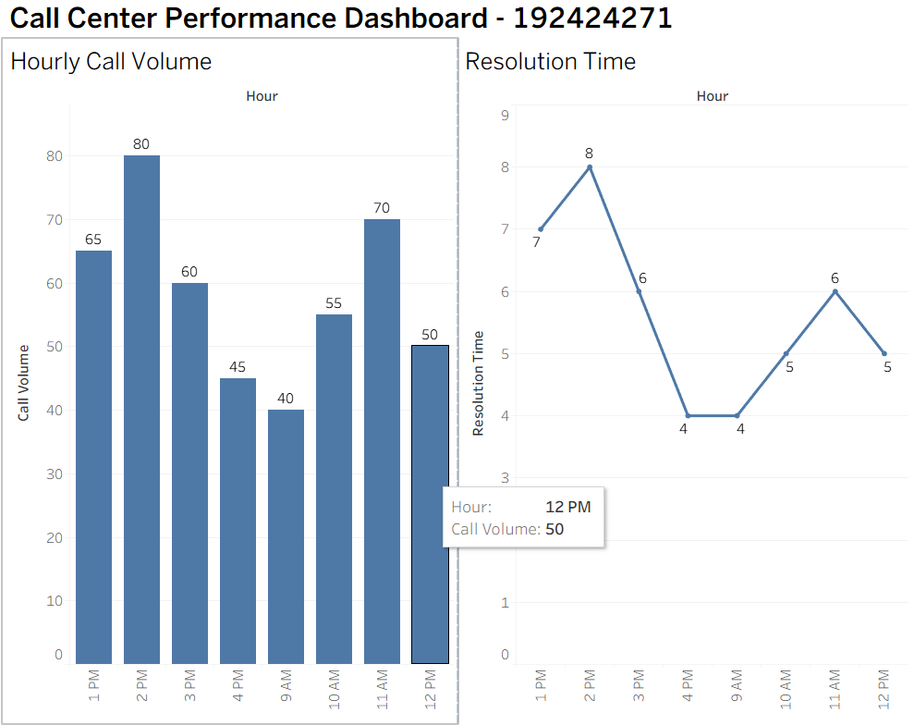
Conclusion
The Call Center Dashboard effectively combines two related visualizations to analyze operational performance. The annotation clearly identifies 2 PM as the peak-stress period requiring additional staffing, while the narrative summarizes the key operational insight. The coordinated dashboard communicates the relationship between workload and service efficiency accurately and clearly, satisfying the Level 4 visualization development requirements.

Problem 17 – Startup Funding Dashboard (5 Marks)
Question
Funding raised and company valuation by investment round:
- Seed = $1M / $5M Valuation
- Series A = $8M / $30M Valuation
- Series B = $20M / $100M Valuation
- Series C = $40M / $250M Valuation
Build a dashboard with a bar chart of funding raised and a line chart of company valuation using a logarithmic scale. Annotate the investment round with the sharpest valuation jump and write a narrative for prospective investors.

Aim
To develop a dashboard that combines funding raised and company valuation across investment rounds, enabling investors to analyze funding growth, valuation growth, and identify the investment round with the highest increase in company value.

Dataset
Investment Round | Funding Raised (Million $) | Company Valuation (Million $)
Seed | 1 | 5
Series A | 8 | 30
Series B | 20 | 100
Series C | 40 | 250

Dashboard Design
The dashboard contains two coordinated charts.
Chart 1 – Bar Chart
- X-axis: Investment Round
- Y-axis: Funding Raised (Million $)
- Purpose: Compare the amount of funding raised during each investment round.
Chart 2 – Line Chart
- X-axis: Investment Round
- Y-axis: Company Valuation (Million $)
- Scale: Logarithmic
- Purpose: Display the growth in company valuation across funding rounds.
Both charts share the same investment rounds, allowing users to compare funding and valuation growth simultaneously.

Annotation
Series C shows the sharpest valuation jump, increasing the company valuation from $100 million to $250 million while raising $40 million in funding.

Narrative Takeaway
The dashboard demonstrates consistent growth in both funding and company valuation across successive investment rounds, with Series C showing the strongest increase in valuation, indicating strong investor confidence and rapid business expansion.

Answer
The dashboard combines a bar chart and a line chart to provide a comprehensive view of startup funding performance.
The bar chart illustrates that funding increases steadily from $1 million during the Seed round to $40 million during Series C.
The line chart uses a logarithmic scale to represent company valuation because the valuation increases rapidly from $5 million to $250 million. A logarithmic scale allows both smaller and larger valuation values to be displayed clearly without compressing the early investment rounds.
The largest valuation increase occurs during Series C, where valuation rises from $100 million to $250 million. This substantial increase reflects strong market confidence and successful business growth.
The annotation highlights this important milestone, allowing investors to quickly identify the round that generated the greatest increase in company value.

Result
The Startup Funding Dashboard successfully combines funding raised and company valuation into a coordinated visualization. It clearly illustrates investment growth, valuation growth, and highlights the most significant valuation increase during Series C.
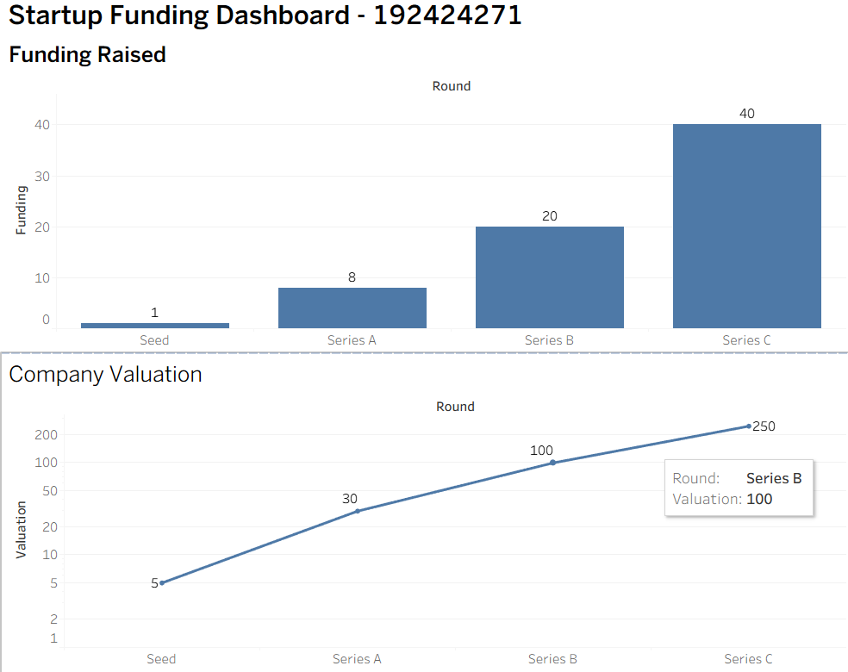
Conclusion
The Startup Funding Dashboard effectively integrates a bar chart and a logarithmic line chart to communicate startup financial growth across multiple investment rounds. The annotation clearly identifies Series C as the round with the sharpest valuation increase, while the narrative summarizes the company's positive investment trajectory. The dashboard presents accurate data, coordinated visualizations, and meaningful insights, satisfying the Level 4 (Exemplary) visualization development requirements.

Problem 18 – Energy Consumption Dashboard (5 Marks)
Question
Monthly electricity usage (kWh) and cost ($):
- January = 450 kWh / $60
- February = 420 kWh / $55
- March = 400 kWh / $52
- April = 380 kWh / $50
- May = 500 kWh / $68
- June = 600 kWh / $130
Build a dashboard with a bar chart of electricity usage and a line chart of electricity cost. Annotate the month with an unusual cost spike relative to usage and write a takeaway suggesting a possible cause.

Aim
To develop a dashboard that combines monthly electricity usage and electricity cost to analyze energy consumption patterns, identify unusual cost variations, and provide insights into possible reasons for higher electricity bills.
\
Dataset
Month | Electricity Usage (kWh) | Electricity Cost ($)
January | 450 | 60
February | 420 | 55
March | 400 | 52
April | 380 | 50
May | 500 | 68
June | 600 | 130

Dashboard Design
The dashboard consists of two coordinated charts.
Chart 1 – Bar Chart
- X-axis: Month
- Y-axis: Electricity Usage (kWh)
- Purpose: Compare monthly electricity consumption.
Chart 2 – Line Chart
- X-axis: Month
- Y-axis: Electricity Cost ($)
- Purpose: Show the monthly electricity cost trend.
Both charts share the same monthly timeline, enabling direct comparison between electricity usage and electricity cost.

Annotation
June shows an unusual cost spike, with electricity cost increasing to $130 while usage reaches 600 kWh. This suggests a possible electricity tariff or rate increase rather than usage alone.

Narrative Takeaway
The dashboard shows that electricity usage generally follows the cost trend; however, the sharp increase in June's electricity bill compared to previous months suggests that a higher electricity tariff or seasonal rate change may have contributed to the increased cost.

Answer
The dashboard combines a bar chart and a line chart to provide a comprehensive view of monthly electricity consumption and associated costs.
The bar chart illustrates monthly electricity usage, which decreases gradually from 450 kWh in January to 380 kWh in April, before increasing to 500 kWh in May and 600 kWh in June.
The line chart shows the corresponding electricity costs. Costs remain relatively stable from $50 to $68 between January and May but rise sharply to $130 in June.
Although June records the highest electricity usage, the increase in cost is proportionally much larger than the increase in usage. This unusual difference indicates that factors other than consumption, such as an electricity tariff revision, seasonal pricing, or additional service charges, may have influenced the final electricity bill.
The annotation highlights June because it represents the most significant deviation between electricity usage and electricity cost.

Result
The Energy Consumption Dashboard successfully combines electricity usage and electricity cost into a coordinated visualization. It clearly identifies June as the month with the highest consumption and an unusually high electricity bill.

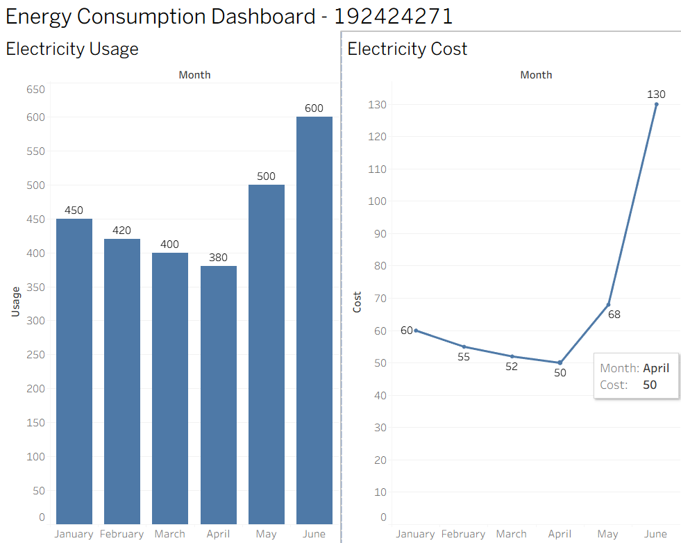
Conclusion
The Energy Consumption Dashboard effectively integrates a bar chart and a line chart to analyze electricity consumption and monthly costs. The annotation clearly identifies June as the month with the most significant cost increase, while the narrative explains that the increase is likely influenced by a change in electricity rates in addition to higher consumption. The dashboard presents accurate data, coordinated charts, and meaningful insights, satisfying the Level 4 (Exemplary) visualization development requirements.

Problem 19 – Online Course Dashboard (5 Marks)
Question
Enrollment and completion rate for five online courses:
- Python = 1,200 / 40%
- Excel = 800 / 70%
- Machine Learning = 1,500 / 25%
- SQL = 600 / 65%
- Design = 900 / 55%
Build a dashboard with a bar chart of enrollment and a bar chart of completion rate for the same courses. Annotate the course with high enrollment but poor completion and write a narrative recommending a course redesign priority.

Aim
To develop a dashboard that compares course enrollment and completion rates to identify courses requiring improvement and support decision-making for course redesign.

Dataset
Course | Enrollment | Completion Rate (%)
Python | 1,200 | 40
Excel | 800 | 70
Machine Learning | 1,500 | 25
SQL | 600 | 65
Design | 900 | 55

Dashboard Design
The dashboard consists of two coordinated charts.
Chart 1 – Bar Chart
- X-axis: Course
- Y-axis: Enrollment
- Purpose: Compare the number of students enrolled in each course.
Chart 2 – Bar Chart
- X-axis: Course
- Y-axis: Completion Rate (%)
- Purpose: Compare the percentage of students who successfully completed each course.
Both charts use the same course categories, allowing direct comparison between enrollment and completion performance.

Annotation
Machine Learning has the highest enrollment (1,500 students) but the lowest completion rate (25%), making it the highest priority for course redesign and learner support improvements.

Narrative Takeaway
The dashboard reveals that although Machine Learning attracts the largest number of learners, its very low completion rate suggests that the course content or learning experience should be redesigned to improve student engagement and completion.

Answer
The dashboard combines two coordinated bar charts to evaluate both student interest and course success.
The Enrollment Bar Chart shows that Machine Learning has the highest enrollment with 1,500 students, followed by Python (1,200 students). SQL has the lowest enrollment with 600 students.
The Completion Rate Bar Chart shows that Excel has the highest completion rate at 70%, followed by SQL (65%), Design (55%), Python (40%), and Machine Learning (25%).
Comparing both charts reveals an important insight: although Machine Learning is the most popular course, it has the lowest completion rate. This indicates that many students enroll but fail to complete the course, suggesting possible challenges such as course difficulty, content complexity, or insufficient learner support.
The annotation highlights this important finding so that decision-makers can immediately identify the course requiring improvement.

Result
The Online Course Dashboard successfully combines enrollment and completion rate into a coordinated visualization. It clearly identifies Machine Learning as the course with the highest enrollment but the lowest completion rate, making it the primary candidate for course redesign.
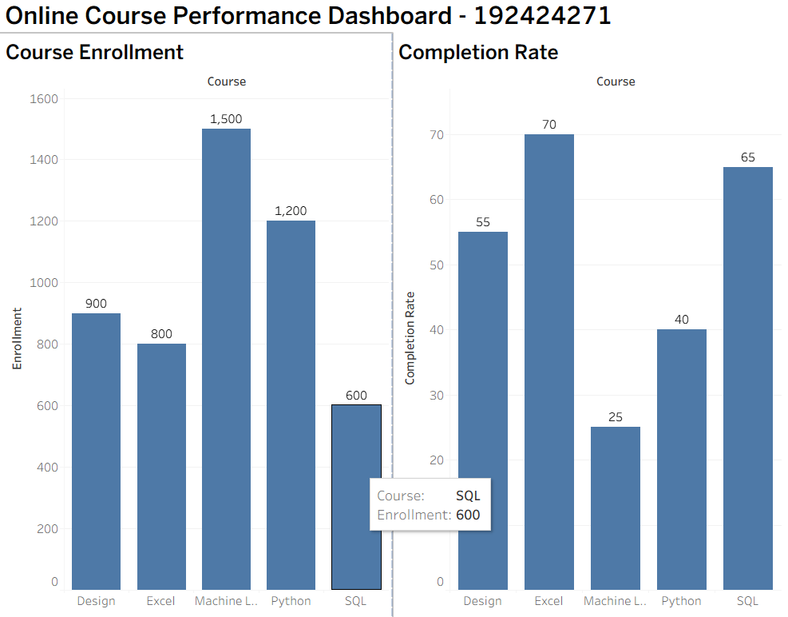
Conclusion
The Online Course Dashboard effectively integrates two coordinated bar charts to compare student enrollment and course completion rates. The annotation clearly identifies Machine Learning as the highest-priority course for improvement, while the narrative summarizes the key insight that high enrollment does not necessarily lead to high completion. The dashboard presents accurate data, coordinated visualizations, and meaningful analysis, satisfying the Level 4 (Exemplary) visualization development requirements specified in the assessment rubric.

Rubrics for Calculation ASSESSMENT RUBRIC
AT2 — Visualization Development Exercise
CO2 · BT4: Analyze ·
This rubric is used to assess student responses to the CO2-AT2 Visualization Development Exercise, in which students build a small multi-chart dashboard from given data, add at least one annotation, and write a narrative takeaway.

Criteria | Weightage | Level 4 – Exemplary | Level 3 – Proficient | Level 2 – Developing | Level 1 – Beginning
Understanding of Concepts | 25% | Demonstrates thorough understanding of which chart types to combine, how they relate to each other, and how annotation and narrative should be used to communicate insight. | Good understanding of chart combination and annotation/narrative technique, with only minor gaps. | Basic understanding of dashboard development, but with some misconceptions about which charts to combine or how to annotate them. | Poor understanding of core development concepts; combines charts or annotations that do not suit the data or the story being told.
Explanation | 25% | The annotation and narrative takeaway are precise, well-justified, and clearly tied to a specific, correctly identified data point or pattern. | The annotation and narrative are clear and reasonably well-justified, with adequate connection to the data. | The annotation or narrative is present but vague, generic, or weakly connected to the actual data shown. | Annotation or narrative is missing, incorrect, or unconnected to the data in the dashboard.
Application | 20% | Effectively applies multi-chart coordination, annotation, and storytelling techniques to produce a complete, cohesive dashboard for the scenario. | Applies development techniques to produce a workable dashboard, with only minor errors or missed refinements. | Limited application; the dashboard partially addresses the scenario but charts feel disconnected or the story is unclear. | Fails to apply appropriate development techniques; the charts, annotation, and narrative do not work together as a dashboard.
Organization | 15% | Charts are clearly coordinated (aligned axes or shared theme), laid out logically, with the annotation and narrative placed for maximum clarity. | Charts are organized and mostly coordinated, with only minor issues in alignment or layout. | Basic structure; charts are present but poorly aligned or the annotation/narrative feels disconnected from the layout. | Poorly organized; charts are not coordinated, and the annotation or narrative is missing or misplaced.
Accuracy | 10% | All chart values, scales, and the annotated data point are completely accurate and correctly reflect the given data. | Mostly accurate, with only minor omissions or a small error in one chart or the annotation. | Partially correct; some plotted values or the annotated point are missing or incorrect. | Largely inaccurate; major errors in plotted values, scales, or the annotated data point.

Scoring Guide
For each criterion, award a performance level (1–4) based on the descriptors above. Multiply the level achieved (as a percentage of 4, i.e., Level 4 = 100%, Level 3 = 75%, Level 2 = 50%, Level 1 = 25%) by the criterion's weightage, then sum across all five criteria to obtain the total score out of 100%.

Faculty In-charge | Course Coordinator | Head of Department
Signature: _______________ | Signature: _______________ | Signature: _______________
Date: ___________________ | Date: ___________________ | Date: ___________________

